Gold Star Roller Service
Koenig & Bauer offers high quality rollers from Bøttcher, inclusive installation at market prices.

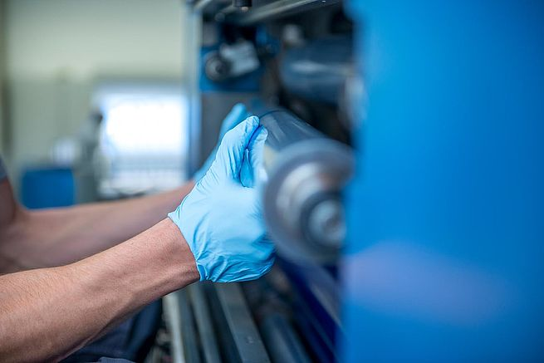
Koenig & Bauer DK is to introduce a brand-new roller service initiative to help printers improve press performance and maintain print quality.
A press with rollers in poor condition or incorrectly set, can cause major production and quality problems for printers. Resolving these problems, can be time consuming and requires an identical skill level across all press crews.
To assist our clients Koenig and Bauer DK has now introduced our “Gold Star Roller Service“. With every complete set of rollers (1 printing unit) ordered from Koenig & Bauer DK, we include a professionally fit and set of rollers. As a customer, you only pay the market price for the rollers. If we do this in connection with a service visit, you do not pay for the travelling time.
The benefits of the Service are as follows:
- The press rollers are fitted and set correctly first time, every time
- Unplanned downtime is reduced
- Consumable costs are reduced
- Quality will be increased
- Roller maintenance can be scheduled to avoid peak production times
Koenig & Bauer offers Gold Star Roller Service for KBA machines, are you interested in getting an offer please contact.
Anita Rytter +45 44 52 32 66
Carsten Hoeg +45 40 28 32 44
Morten Rasmussen +45 20 98 88 16

